- Introduction
Construction job sites are dynamic environments involving various workers, equipment, and machines operating simultaneously, resulting in managing such job sites a complex and challenging task (Alaloul et al. 2022). Compared with some other engineering sectors such as automotive and aerospace, construction is heavily labor intensive, has a vast and diverse supply chain, and is dominated heavily by single point and ad-hoc solutions, which results in considering every project is different (Davila Delgado and Oyedele 2021). Because construction sites have these characteristics, standard industrial monitoring systems are often not practical for use in the construction industry (Alaloul et al. 2022).
Due to this profound complexity, regular safety inspections are needed to keep the work environment hazard-free (Asadzadeh et al. 2020). Additionally, managers must monitor and track activities and ensure the project meets the expected production rates (Alaloul et al. 2022). However, traditional manual observation and reporting methods, such as physical site walk-throughs for hazard identification or the manual logging of Daily Construction Reports (DCRs) heavily rely on subjective and error-prone manual visual inspection procedures (Samsami 2024). Furthermore, these manual methods are time-consuming, labor-intensive, and result in a slow information flow (Alaloul et al. 2022).
The absence of real-time information resulting from these manual limitations hinders monitoring schedule, cost, and other performance indicators, reducing the ability to reveal or manage the variability and uncertainty inherent in project activities (Alaloul et al. 2022). Because of these systemic bottlenecks, the industry persistently struggles to overcome the issues associated with safety hazards and low productivity (Jiang and Messner 2023). Consequently, there is a growing interest in the construction industry in adopting AI technologies for various management and construction tasks (Rabbi and Jeelani 2024), with computer vision emerging as a prominent solution to capture and analyze data from these complex sites (Paneru and Jeelani 2021).
To overcome the data deficiencies of traditional manual methods, research initially shifted toward automated object-level data collection (Tuomisto et al. 2026). Rather than broadly applying automation to all construction tasks, this specific technological domain focused on developing automated, real-time performance monitoring systems consisting of location tracking, activity recognition, and performance monitoring (Sherafat et al. 2020). To achieve this, the first of these methods involved attaching tracking devices like Radio Frequency Identification (RFID), Ultra-Wideband (UWB), or Bluetooth Low Energy (BLE) to building components (Tuomisto et al. 2026). However, while these tag-based methods are effective for locating materials, they cannot verify the proper installation or condition of components, limiting their utility for detailed inspection tasks (Tuomisto et al. 2026). Furthermore, tracking eventually thousands of items do not offer an economical or practical approach in large-scale projects (Bohn and Teizer 2010; Chen et al. 2023). Eventually, the industry shifted toward computer vision techniques to address this problem, as they operate without requirements to attach any sensors and enable more comprehensive on-site information, such as the locations and activities of construction entities, bringing operational and technical advantages over various wearable sensors (Xiong et al. 2019).
Building upon the shift toward camera-based monitoring, traditional computer vision approaches utilizing bounding-box detectors have been widely adopted to locate construction entities. While these models are highly effective at spatial localization, identifying only the workers and PPE components, without recognizing the contextual relationship between them, does not effectively verify PPE compliance (Nath, Behzadan, and Paal 2020). Specifically, inferring that workers are prone to experience falling from height based on safety regulations is difficult for computer vision; this condition can be summarized as a semantic gap (Wu et al. 2021). Because computer vision cannot natively comprehend safety rulebooks, traditional pipelines attempted to bridge this gap by applying an algorithm with explicit rules that are determined through empirical observations (Nath et al. 2020). However, manually establishing these rules for multiple PPEs is a complicated task and results may not be structured or comprehensive enough to consider all possible scenarios (Nath et al. 2020).
To overcome the limitation of manual geometric mapping, research explored an alternative approach using Natural Language Processing (NLP) for automatically extracting regulatory requirements from textual regulatory documents and formalizing these requirements in a logic format (Zhang and El-Gohary 2015). Yet, while NLP excels at rule extraction, these text-based models are fundamentally blind to the physical site. Ultimately, they simply represent the extracted safety requirements in the form of query graphs for supporting subsequent knowledge graph-based field compliance checking (Wang and El-Gohary 2023). Consequently, this creates a profound technological disconnect that computer vision can see the site but cannot understand the rules, while NLP understands the rules but cannot see the site. This fundamental limitation necessitates the emergence of multimodal Vision-Language Models (VLMs) capable of natively fusing both data streams.
To address the fundamental limitations of traditional methods in processing semantic information, recent advancements have introduced multi-modal large language models (MLLMs) upon which vision-language models (VLMs) combine image processing and natural language processing (NLP) (Chan et al. 2025). By extracting both intricate visual and linguistic features, these models can perform multiple types of instruction-following tasks such as image captioning, visual grounding, and visual question answering (VQA) (Chan et al. 2025). Furthermore, these architectures acquire generalized visual representations guided by natural language supervision, enabling impressive zero-shot detection capabilities (Zhang et al. 2025). By leveraging natural language prompts and contextual reasoning, VLMs offer a flexible approach for spatiotemporal analysis interpreting both the spatial geometry of hazards and the temporal sequence of complex human behaviors on dynamic construction sites, potentially reducing the dependence on extensive labeled datasets (Bui, Chodosh, and Tavakoli 2026). Consequently, these multimodal systems can create human-readable captions for daily progress and work activity logs (Jung et al. 2024), while simultaneously supporting interactive question-and-answer sessions, fostering a more informed understanding of construction site safety (Hussain et al. 2026).
Despite the rapid emergence of VLMs as a paradigm-shifting technology, existing systematic reviews have remained siloed in their respective unimodal domains. The majority of existing reviews on AI applications in the construction industry tend to focus on specific domains within AI, such as computer vision or NLP, thereby addressing only fragments of the potential AI applications (Rabbi and Jeelani 2024). For instance, previous reviews have extensively mapped pure computer vision research in construction (Jiang and Messner 2023; Paneru and Jeelani 2021; Zhong et al. 2019) or provided overviews of sensor-based safety management (Asadzadeh et al. 2020). While these studies provide valuable baselines, existing reviews do not cover the latest technological advances and lack systematic elaboration for construction scene understanding (Zhang et al. 2025). Specifically, although Vision-Language Models (VLMs) excel in general multimodal tasks, their ability to understand human behavior in safety-critical construction environments remains largely unexplored (Bui et al. 2026). Due to the development of scene understanding and large language models in recent years, it is necessary to conduct a new review on this topic to capture these paradigm-shifting advancements (Zhang et al. 2025).
To address this critical gap, this paper presents a comprehensive scoping review of multimodal vision-language systems applied to construction safety and progress monitoring. Conducted in strict accordance with the PRISMA-ScR guidelines (Tricco et al. 2018), the specific objectives of this study are to: (1) map the current landscape of VLM applications in construction management; (2) develop a robust taxonomy bridging foundational VLM architectures with practical construction management applications; and (3) analyze existing algorithmic limitations to outline a roadmap for future research in construction. To achieve these objectives, this review seeks to explicitly answer the following four primary research questions (RQs):
- RQ1: What are the prevalent Vision-Language Model (VLM) architectures currently utilized for spatiotemporal analysis in construction?
- RQ2: How is multimodal data (visual and textual) fused and processed to evaluate safety hazards on active sites?
- RQ3: What are the primary methodological bottlenecks in deploying these models for real-time progress tracking and safety?
- RQ4: How is the performance of Vision-Language Models currently evaluated and benchmarked for spatiotemporal tasks in construction?
- Research Methodology
This review was conducted in accordance with the PRISMA-ScR (Preferred Reporting Items for Systematic Reviews and Meta-Analyses extension for Scoping Reviews) guidelines (Tricco et al. 2018). A scoping review design was deliberately selected over traditional quantitative meta-analysis for two primary reasons. First, Vision-Language Models (VLMs) have emerged as a promising tool for visual understanding tasks (Bui et al. 2026), and recent studies are widely investigating these multi-modal feature mining pipelines to shed light on novel opportunities in the construction industry (Chan et al. 2025; Chen et al. 2024); thus, the primary objective is to map the extent, range, and nature of this novel architecture rather than to compare narrow intervention effects. Second, the evaluation metrics across the included studies exhibit substantial methodological heterogeneity; ranging from geometric precision metrics, such as mean Average Precision (Nath et al. 2020; Wang and El-Gohary 2024), to natural language generation metrics, such as BLEU and CIDEr (Jung et al. 2024; Xiao, Wang, and Kang 2022), which renders a standardized statistical meta-analysis inappropriate.
2.1 Search Strategy and Information Sources
To ensure a rigorous and reproducible retrieval process, the literature search was conducted on 4th March 2026 across two of the most comprehensive scientific databases for engineering and computer science research: the Web of Science (WoS) Core Collection and Scopus. These specific databases were selected because the WoS contains the most comprehensive and influential journals within the field of construction and engineering management (Zhong et al. 2019), and Scopus is actively used alongside WoS as a primary search engine for AI applications in the construction domain (Rabbi and Jeelani 2024).
The keywords were determined by analyzing frequent words found in papers where AI was applied to enhance construction management and safety (Rabbi and Jeelani 2024). The search query was constructed using a tripartite Boolean logic framework designed to intersect three distinct conceptual domains: (1) the specific AI architecture (Multimodal vision-language systems), (2) the analytical task (spatiotemporal and dynamic reasoning), and (3) the application domain (construction management). The exact search strings applied across both databases are as follows:
- String 1 — AI Architecture: ("Vision-Language Model*" OR "VLM" OR "Vision-Text" OR "Image-Text" OR "Visual Question Answering" OR "VQA" OR "Image Captioning" OR "CLIP" OR "Large Multimodal Model*" OR "LMM" OR "Foundation Model*" OR "Generative AI" OR "Video-Language" OR "Video-Text") AND
- String 2 — Analytical Task: ("Spatiotemporal" OR "Spatio-temporal" OR "Video" OR "Temporal" OR "Dynamic" OR "Time-series" OR "4D" OR "Motion" OR "Tracking" OR "Sequenc*" OR "Action recognition" OR "Activity recognition") AND
- String 3 — Application Domain: ("Construction Management" OR "Civil Engineering" OR "AEC" OR "Infrastructure" OR "Built Environment" OR "Construction Site" OR "Safety Monitoring" OR "Structural Health Monitoring" OR "Digital Twin")
Given the rapidly evolving nomenclature of VLM research, relying purely on an algorithmic, keyword-based search poses a risk of omitting foundational or transitional works that may not employ contemporary terminology. To address this limitation, a secondary backward snowballing (ancestry/reference chain) strategy was employed. The reference lists of all articles retained after the full-text review were systematically mined to identify foundational or transitional technologies, ensuring that some articles that were missed during the keyword search process were identified from using reference chains (Rabbi and Jeelani 2024).
2.2 Eligibility Criteria
To maintain a disciplined and reproducible scope in accordance with the PRISMA-ScR guidelines (Tricco et al. 2018), explicit inclusion and exclusion criteria were established a priori, prior to the commencement of the screening process. These criteria were strategically designed to isolate high-quality literature that directly addresses the intersection of multimodal AI and active construction management, as narrowing the selection to reputable peer-reviewed journals enhances the reliability and relevance of the chosen studies (Rabbi and Jeelani 2024). Furthermore, the criteria deliberately retain a select number of traditional unimodal Computer Vision (CV) and Natural Language Processing (NLP) papers to establish an evolutionary comparative baseline. This baseline is essential to empirically demonstrate the inherent limitations of prior technologies and the "semantic gap," which indicates the limitation of computer vision systems in extracting the visual data of what the cameras "see" (Wu et al. 2021). The exact criteria applied during the screening process are summarized in Table 1.
Table 1. Summary of inclusion and exclusion criteria.
Dimension | Inclusion Criteria | Exclusion Criteria
Publication Date | 2019–2026 (for core VLM literature); 2010–2026 (for foundational CV baselines). | Pre-2010; post-March 2026.
Source Type | High-impact Peer-reviewed journal (Rabbi & Jeelani, 2024). | Editorials, book chapters, theses, documents not written in English (Li, Deng, and Deng 2025), and conference proceedings and industry white papers (Rabbi and Jeelani 2024).
Technology | Multimodal architecture integrating visual/geometric data with textual/semantic data (e.g., VLMs, VQA, Image Captioning, CLIP-based models, MLLMs). | Purely unimodal CV (e.g., standalone YOLO, CNN bounding-box detectors) or purely text-based NLP, unless serving as an explicit comparative baseline within a hybrid framework.
Application Domain | Active construction phase: Safety Management (hazard identification, PPE compliance) and Progress Tracking (productivity analysis, schedule monitoring, reporting). | Post-construction, facility management, structural health monitoring, or non-engineering domains.

2.3 Selection of Sources of Evidence
The selection process for sources of evidence was conducted in two sequential phases: primary database retrieval and backward snowballing, and is visually summarized in the PRISMA-ScR flow diagram (Figure 1) (Tricco et al. 2018).
During Phase 1, the initial query across the Web of Science and Scopus databases yielded 1,443 raw records (769 from WoS and 674 from Scopus). Automated database filters restricting the results to relevant subject areas, the English language, and peer-reviewed document types excluded 1,320 records, leaving a targeted pool of 123 articles. Applying these filters is a standard practice to refine the scope of the results (Li et al. 2025) and to narrow the selection to articles published within reputable peer-reviewed journals, enhancing the reliability and relevance of the chosen studies (Rabbi and Jeelani 2024). After removing 33 duplicate records identified across the two databases, 90 unique articles remained for manual screening.
A rigorous two-stage manual screening protocol was subsequently employed to prevent selection bias, aligning with established scoping review methodologies (Tricco et al. 2018). In the first stage, title and abstract screening was conducted by a primary reviewer and validated by an expert academic reviewer, resulting in the exclusion of 32 articles that fell outside the scope of the active construction context. The remaining 58 articles were advanced to full-text review. During this second stage, 33 articles were excluded due to an exclusive focus on domains outside the active construction phase, insufficient methodological detail regarding their multimodal architectures, or reliance on unimodal architectures that did not belong to the baseline-to-VLM progression. This rigorous filtration process yielded a Phase 1 dataset of 25 core VLM and transitional articles.
Concurrently, Phase 2 was executed via a backward snowballing (reference list mining) search of the retained articles. This strategy was utilized because more relevant articles can be identified from these papers by using reference chains, which helps identify important articles that were missed during the keyword search process (Paneru and Jeelani 2021; Rabbi and Jeelani 2024). This ancestry search successfully identified an additional 31 highly relevant baseline and transition articles.
Integrating the Phase 1 database retrieval and Phase 2 snowball search culminated in a final, robust corpus of 56 articles included in this review. As represented in the final corpus synthesis, this dataset is methodologically balanced, comprising 31 baseline/background papers, 5 transition/bridging papers, and 20 core construction VLM papers. Curating the literature across this specific timeframe provides the necessary temporal data to present how these methods applied in the construction phase have evolved over the years (Jiang and Messner 2023).
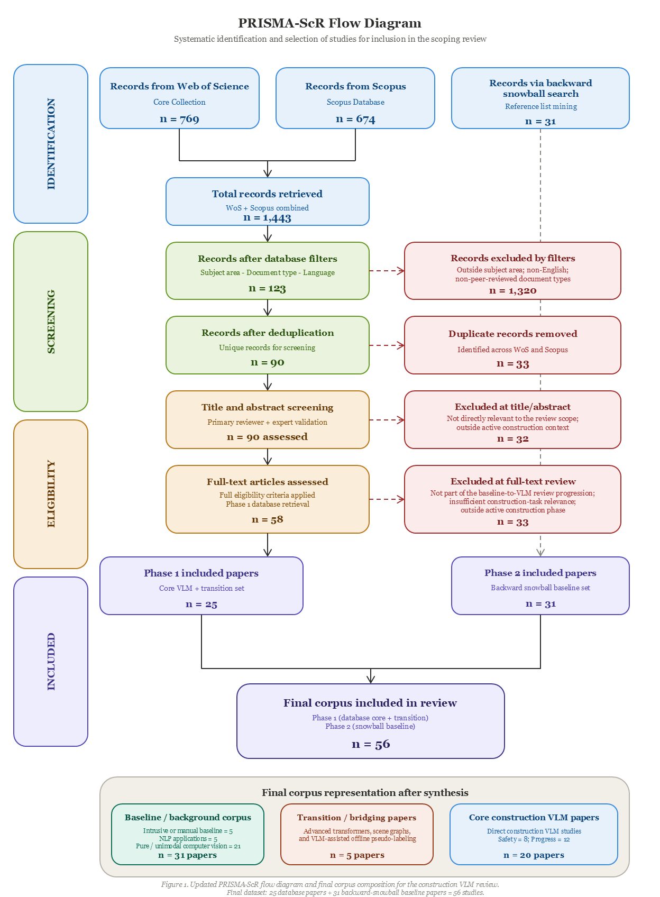
2.4 Data Charting and Extraction Process
Following the selection of the 56 core articles, a standardized data extraction framework was developed to systematically chart the literature. As recommended by scoping review methodologies (Tricco et al. 2018), the data charting form was iteratively refined by the research team to ensure all relevant variables addressing the research questions were captured consistently.
To provide a structured and comprehensive evaluation of the literature, the extracted data were systematically categorized into three distinct analytical dimensions: Content Analysis, Technical Analysis, and Critical Analysis. The complete data charting framework and its corresponding extraction variables are detailed in Table 2.
Table 2. Data Charting and Extraction Framework.
Analytical Dimension | Extraction Variables | Description
Dimension 1: Content Analysis | Cluster/Application; Input Data; Spatiotemporal Task; Automation Level. | Identifies what the AI is doing by mapping the specific domain (e.g., safety vs. progress tracking), the sensory inputs utilized (e.g., video, image, point cloud), the specific spatiotemporal task (e.g., action recognition, tracking), and the system's level of autonomy (assistive vs. automated).
Dimension 2: Technical Analysis | Algorithm/Model; Dataset; Validation Metric; Compute/Hardware. | Analyzes how the system operates by documenting the specific architectures (e.g., GPT-4o, CLIP), the nature of the training data (public vs. private/custom), the diverse evaluation metrics employed (e.g., mAP, F1-score), and the deployment environment (edge vs. cloud).
Dimension 3: Critical Analysis | Key Limitation; Research Gap; Future Direction. | Evaluates the significance of the study by synthesizing the inherent technological or methodological bottlenecks, identifying unmet industry needs, and charting actionable future research trajectories.

2.5 Data Synthesis
Given the heterogeneous nature of the evaluation metrics across the included studies—which range from geometric intersection-over-union (IoU) and mean average precision (mAP) metrics for measuring bounding box predictions (Nath et al. 2020; Wang and El-Gohary 2024) to semantic fluency metrics for evaluating image captioning models, such as BLEU, METEOR, and CIDEr (Jung et al. 2024; Xiao et al. 2022); a standardized quantitative meta-analysis was deemed inappropriate. Instead, a thematic and narrative synthesis approach was adopted to map the literature (Tricco et al. 2018). To directly address the research questions regarding architectural evolution and multimodal data fusion, the extracted data were synthesized to present how these methods applied in the construction phase have evolved over the years (Jiang and Messner 2023). The final corpus of 56 papers was thematically classified into three distinct developmental stages: (1) the traditional baseline establishing the geometric-semantic disconnect, (2) the transitional bridge leveraging advanced but unimodal algorithms, and (3) the paradigm shift toward end-to-end Vision-Language Models (VLMs). This thematic categorization forms the structural foundation for the subsequent scientometric and thematic analyses presented in Chapters 3, 4, and 5.

Chapter 3
- Journal list, no of papers, citescore, SJR impact factor – table 2
- Previous Review studies – table 1.
- documents cocitation cluster table
- highly cited articles
- id-idf keyword for each year
- top-10 cited authors,
- Graphs – most frequently used keywords, frequency of technology used (heatmap), Network of frequently used keywords, document co citation networks, word cloud, co-occurences mapping of keywords, journal cocitation network, author cocitation map, collaboration network by institute, collaboration network of authors, Articles reviewed- categorized by application area, mind map

Frequently – not meta-analysis
Map: Publication trends, geographic mapping, study characteristics (designs, methodologies, participants); research frequent methodologies, interventions

Number of studies, publication years, countries/regions, journals, types of publication
Study characteristics – research design, data sources, sample population, sample sizes, setting
Topic/Content characteristics: what outcomes examined, what was considered,
Methodological – modeling approaches, statistical techniques, ML methods, survey methods, logistic vs cross-sectional designs
Theories – Theories used, conceptual frameworks (or if there isn’t any theoretical grounding)

Chapter 4: Thematic Analysis – Vision-Language Model Architectures
Following the descriptive mapping of publication trends, this thematic analysis shifts focus to observe and report on the actual activities within a field. While previous scientometric mappings focused more on the contributing authors and geographic origins of the literature, the current study emphasizes the specific technical applications and methodological mechanisms of computer vision research in construction. Compiling literature in this manner enables the identification of issues, opportunities and challenges that are not currently well covered and examined. Yet, there is a need to develop a framework of the CV approaches that can be applied to construction use cases to inform future research and development activities. To systematically structure this review and address this need, the following sections propose a Three-Layered Spatiotemporal VLM Framework. By exploring the chronological evolution of these algorithms (Layer 2: The Engine Layer), this chapter explicitly addresses RQ1 (prevalent VLM architectures) and RQ2 (multimodal data fusion) by demonstrating how raw visual and textual inputs (Layer 1: Multimodal Inputs) are mathematically fused. Ultimately, mapping the engine layer establishes the seamless foundation for analyzing their practical construction applications in Chapter 5 (Layer 3: The Output Layer).
4.1 The Three-Layered Spatiotemporal VLM Framework
To systematically map the rapid technological shifts in construction AI, the proposed Three-Layered Spatiotemporal VLM Framework was established to capture the field's chronological progression. The structural decision to constrain this framework to precisely three layers is not arbitrary; rather, it is fundamentally grounded in the established continuum of human information processing for automated systems. In automated environments, decisions are derived from functions that replicate human cognition, categorized into three primary hardware and software mechanisms: sensors, processors, and actuators (Czarnowski et al., 2020; Parasuraman et al., 2000).
The architecture of this framework maps directly to these three interdependent cognitive stages. Layer 1 functions as the "sensory" acquisition stage, consisting of multimodal inputs where raw visual data streams are captured alongside textual domain knowledge and kinematic sensor data. Layer 2 represents the Spatiotemporal VLM Core, acting as the "processor" that handles perception and decision-making by mimicking human cognitive functions through algorithmic design (Czarnowski et al., 2020). This engine layer is critically necessary since approaches for representing linguistic information of regulatory rules using graph structure have not yet emerged, given that the pairwise relationships in traditional scene graphs cannot represent the complex relationships in regulatory rules (Chen et al., 2022). Consequently, Layer 2 categorizes the algorithmic solutions into three chronological paradigms: Zero/Few-Shot Prompting, Domain Fine-Tuned VLMs, and Hybrid Geometric-Semantic Systems. Finally, Layer 3 serves as the "actuator" stage, translating these cognitive engine processes into actionable physical outputs and construction management tasks, divided primarily into safety management and progress tracking.
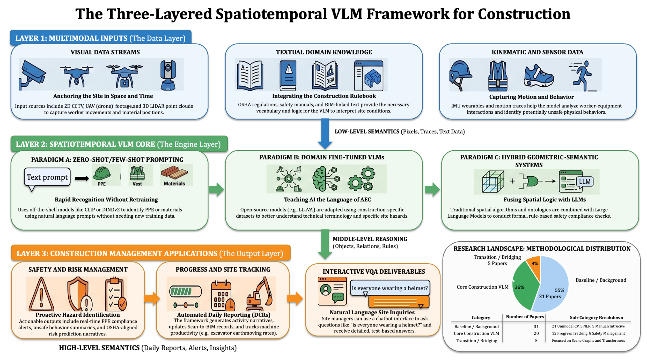
This tripartite structure aligns perfectly with the required progression of construction scene understanding, illustrating the evolution from rule-based learning to end-to-end learning by categorizing the flow of data from raw inputs to high-level semantics, and ultimately to automated interventions (Li et al., 2025). Crucially, this framework explicitly emphasizes spatiotemporal analysis due to the highly dynamic nature of construction job sites, requiring models to track entities across both physical space and continuous time. For instance, detecting moving objects in construction sites and tracking equipment cycles necessitates temporal video analysis rather than static image processing. By fusing spatial geometry with temporal sequence tracking, these models offer a comprehensive overview of existing research for the purpose of identifying gaps in the body of knowledge and anticipating future research directions. To understand the operational mechanics of this spatiotemporal engine, it is necessary to first examine the earliest applications of foundation models that attempted to extract information independent of task-specific retraining.

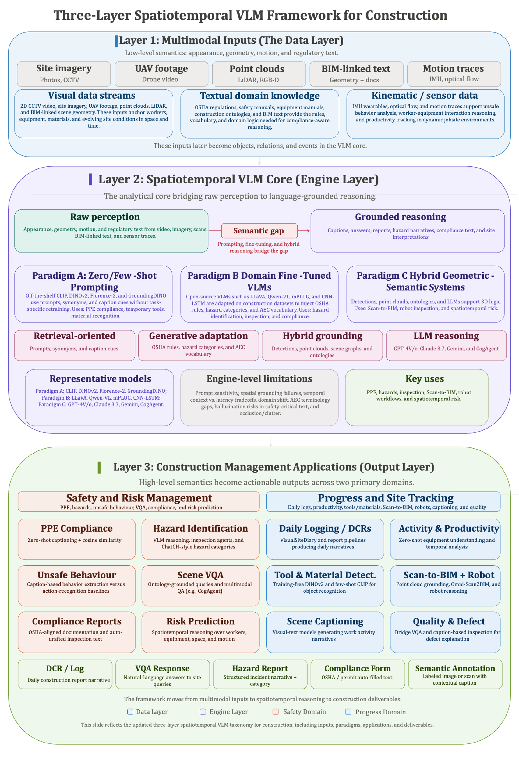
4.2 Paradigm A: Zero/Few-Shot Prompting (Retrieval-Oriented)
The deployment of traditional computer vision on construction sites has historically been bottlenecked by the need for extensive annotated datasets. Because traditional supervised learning methods suffer from high annotation costs, severe computational demands, and limited datasets, scaling these systems to cover every potential hazard or piece of equipment has proven prohibitively labor-intensive (Zhang et al., 2025). To circumvent this strict reliance on massive data collection, the construction research community began seeking training-free alternatives. This search led to the adoption of foundational Vision-Language Models (VLMs), such as Contrastive Language-Image Pre-training (CLIP), DINOv2, and Florence-2. Rather than relying on rigid numerical labels defined during a lengthy training phase, these multimodal methods acquire generalized visual representations guided by natural language supervision, enabling impressive zero-shot detection capabilities without requiring task-specific retraining (Zhang et al., 2025).
The operational mechanics of this retrieval-oriented paradigm rely on embedding both visual and textual inputs into a shared semantic space, effectively allowing language to guide visual perception. For instance, contrastive pre-training enables the model to train an unseen class using only its description in the text (Gil & Lee, 2024). By transforming class names into descriptive text prompts, the cosine similarity between query visual features and N text prompts from the target dataset is measured to classify the objects (Liang et al., 2024). This shared embedding space completely alters how algorithms process site data. State-of-the-art models like Florence-2 are capable of open vocabulary object detection, meaning they can detect objects described by a text prompt without being limited to predefined classes (Jeoung et al., 2025). By simply altering the textual query, researchers have successfully deployed this retrieval paradigm to recognize temporary construction site objects (Liang et al., 2024), track the tasks of heavy earthmoving equipment (Jeoung et al., 2025), and verify personal protective equipment (PPE) compliance through semantic text similarity (Gil & Lee, 2024).
However, while zero-shot and few-shot prompting successfully mitigates data scarcity by extracting bounding boxes and object tags, this paradigm suffers from a fundamental limitation in semantic expressiveness. Because current VLMs are trained on broad, general-purpose datasets, they lack optimization for task-specific applications like construction site monitoring (Bui et al., 2026). Specifically, these foundational models cannot deal with domain-specific knowledge directly because they are pre-trained on general objects and remain unfamiliar with complex architectural and engineering technical terms (Gil & Lee, 2024). More critically, this retrieval paradigm merely outputs discrete object locations and isolated labels. It fundamentally lacks the capacity to generate coherent, human-readable narratives that describe the continuous interactions and ongoing activities within an active scene. To address this descriptive gap and translate visual data into comprehensive situational awareness, researchers transitioned toward generative adaptation, marking the critical evolutionary shift to Paradigm B.

4.3 Paradigm C: Hybrid Geometric-Semantic Systems and Ontologies
To overcome the descriptive gap left by zero-shot retrieval models, the construction research community recognized that outputting isolated object tags was insufficient for comprehensive site monitoring. Consequently, the industry transitioned toward generative adaptation by adopting image captioning algorithms. Unlike traditional object detection that merely outputs discrete labels, image captioning combines computer vision and natural language processing to translate visual information into comprehensive natural language descriptions (Liu et al., 2020). The operational mechanics of this paradigm typically rely on an encoder-decoder framework, where a visual encoder (such as a CNN) extracts image embedding features, and a language decoder (such as a recurrent neural network) generates the corresponding text sequences (Xiao et al., 2022). By training these generative architectures directly on custom construction datasets, the models successfully acquire domain-specific vocabulary and can manifest complex construction activity scenes into human-readable narratives (Liu et al., 2020).
This ability to generate semantically rich sentences completely transformed automated construction management, particularly in automating tedious administrative and safety documentation. For safety management, integrating deep learning object detection with image captioning enabled safety systems to generate rich text with semantic information to proactively identify hazards (Wang et al., 2024). In the domain of progress tracking, this paradigm enabled the automated generation of daily logs. For instance, recent architectures like VisualSiteDiary utilize a detector-free Vision-Language Transformer model for captioning photologs to support daily construction reporting (Jung et al., 2024). By fine-tuning the transformer on diverse site images, the system successfully extracts actionable insights around the "where," "how," and "what" of the work that happened on-site on a particular calendar date (Jung et al., 2024).
However, despite these remarkable advances in scene description, domain fine-tuned captioning suffers from a severe interactive limitation. While generative fine-tuning successfully creates descriptive sentences, it remains a strictly one-way, static process. Existing deep learning applications in this paradigm lack the capability to provide context-specific and interactive feedback that is essential for workers to fully understand their surrounding environments (Chen et al., 2024). Because a captioning model generates a fixed narrative and stops, site managers cannot ask it follow-up questions, query it about specific unmentioned hazards, or ask it to dynamically cross-reference its visual findings against complex, multi-step safety rulebooks. To resolve these limitations in user interactivity and facilitate dynamic querying, recent methodologies have advanced beyond static captioning toward the deployment of agentic Large Multimodal Models (MLLMs), marking the critical evolutionary shift to Paradigm C.
4.4 Paradigm C: Hybrid Geometric-Semantic Systems (Agentic & Hybrid Stacks)
To overcome the interactive bottleneck of static image captioning, the construction research community shifted toward agentic Large Multimodal Models (MLLMs). While previous paradigms successfully described scenes, they struggled to correlate visual observations directly with complex regulatory codes due to inherent limitations in geometric reasoning (Hussain et al., 2026). To bridge this gap, Paradigm C introduces hybrid frameworks that combine precise geometric reasoning (such as bounding box coordinates or Building Information Modeling data) with LLM-powered interpretation to achieve true, regulation-aware scene understanding (Hussain et al., 2026).
The operational mechanics of these hybrid systems rely on fusing object detection arrays with conversational AI and explicit domain ontologies. For instance, recent intelligent assistant systems utilize YOLO architectures to extract the precise geometric coordinates of workers and equipment, and then feed those detections directly into an MLLM as text prompts (Hussain et al., 2026). This allows an interactive chatbot within the application to present the generated safety caption to the user while allowing for further discussion, questions, or additional information in a dynamic, two-way dialogue (Hussain et al., 2026). To ensure these MLLMs do not hallucinate and strictly adhere to industry standards, researchers have developed hierarchical prompting frameworks driven by a construction safety ontology, which explicitly embeds construction-related knowledge into the model as part of the prompts (Chan et al., 2025). By operating as a human-alike virtual assistant agent, these multi-modal models can perform complex visual question answering (VQA) to interactively check compliance, such as confirming if a worker is maintaining three-point contact or attached to a secure anchorage point (Chan et al., 2025).
This hybrid, agentic paradigm has rapidly expanded the boundaries of automated construction management across both time and physical space. In the temporal domain, MLLMs are now being deployed to process multiple consecutive video frames, enabling complex spatial inference, task inference, and temporal event analysis to monitor the continuous operational tasks of heavy equipment over time (Jeoung et al., 2025). In the spatial domain, these vision-language models have been integrated directly with quadruped robots and Building Information Modeling (BIM) (Tuomisto et al., 2026). As the robot autonomously navigates a site, the VLM actively compares captured images against metadata extracted from the IFC (Industry Foundation Classes) model to deliver programmatic assessments on whether specific architectural elements are actually present and installed correctly (Tuomisto et al., 2026).
However, while Paradigm C represents the absolute cutting edge of spatiotemporal construction scene understanding, it is not without critical vulnerabilities. The literature explicitly notes that despite significant progress in compliance checking, these advanced models are still challenged by dynamic scenarios and complex behavioral detection (Hussain et al., 2026). Furthermore, their reliance on complex prompt engineering and their sensitivity to environmental noise introduces new risks of latency and unreliability in safety-critical settings.

Chapter 5: Thematic Analysis – Construction Management Applications
This chapter investigates how the cognitive processes of Vision-Language Models (VLMs) are translated into actionable construction management deliverables. Within the built environment, the high-level semantic outputs generated by these models—such as captions, Visual Question Answering (VQA) responses, and compliance reports—are predominantly deployed across two critical operational domains. Section 5.1 explores the application of these models in Safety and Risk Management, tracing the progression from basic compliance checks to interactive hazard querying. Subsequently, Section 5.2 examines Progress Tracking and Automated Reporting, detailing how multimodal AI automates site logging and complex equipment tracking workflows.
5.1 Domain A: Construction Safety and Risk Management
Historically, the integration of computer vision into safety management began by targeting the most visible and easily preventable hazards, specifically the absence of Personal Protective Equipment (PPE). Utilizing Paradigm A zero-shot retrieval architectures, early automated frameworks verified PPE compliance without requiring task-specific training. By extracting human skeletal key points, these systems cropped individual body-part images and compared generated image captions against natural language prompts describing OSHA safety regulations, determining PPE compliance through cosine similarity (Gil & Lee, 2024). However, while identifying whether a worker is wearing a hardhat is a critical first step, safety incidents often arise from complex spatiotemporal interactions rather than mere equipment absence. While identifying the presence of PPE is a foundational requirement, comprehensive risk management must also evaluate complex spatiotemporal interactions, as workers may be fully equipped yet still engage in high-risk operational behaviors.
To comprehensively capture these risky interactions, the industry shifted toward Paradigm B, utilizing domain fine-tuned generative models to analyze unsafe behaviors. By integrating deep learning object detection with image captioning, safety systems gained the capability to extract semantic information and generate rich textual descriptions of active scenes, enabling the proactive identification of hazards by matching these visual descriptions against text-based safety rules (Wang et al., 2024). Yet, despite successfully generating descriptive safety narratives, these systems remained static and lacked context-specific, interactive feedback essential for workers to fully comprehend their surrounding environments (Chen et al., 2024).
To break through this interactive bottleneck, safety monitoring evolved into Paradigm C, deploying hybrid agentic Large Multimodal Models (MLLMs) capable of complex reasoning and dialogue. For instance, the Visual Construction Safety Query (VCSQ) system integrates real-time image captioning and safety-centric VQA with head-mounted Augmented Reality (AR) devices, allowing workers to actively query the system about surrounding hazards on-demand (Chen et al., 2024). Furthermore, to ensure these agentic models do not hallucinate and strictly adhere to regulatory codes, researchers have developed human-alike virtual assistants driven by explicit construction safety ontologies. By injecting specific domain knowledge into the model's prompting framework, these systems can perform complex VQA to check multi-step compliance, such as verifying work-at-height regulations (Chan et al., 2025). Similarly, mobile-based intelligent assistants now combine precise geometric reasoning from object detectors with LLM-powered interpretation to generate comprehensive hazard captions and facilitate interactive safety discussions with site inspectors (Hussain et al., 2026).
However, despite these profound advancements in identifying physical hazards and compliance violations, current general-purpose VLMs still struggle to interpret deeply nuanced visual cues, such as distinguishing whether a crew is effectively collaborating or simply communicating (Bui et al., 2026). Furthermore, mitigating safety risks represents only one half of the site management equation. The exact same spatiotemporal engines that evaluate hazards are simultaneously required to monitor site productivity, effectively forcing the industry to adapt these multimodal systems for progress tracking.

5.2 Domain B: Progress Tracking and Automated Reporting
While ensuring worker safety remains the paramount priority of site management, mitigating risks represents only half of the operational equation. The exact same spatiotemporal engines deployed to identify hazards are simultaneously utilized to monitor site productivity and automate administrative documentation. The foundation of automated progress tracking requires a fundamental understanding of where site resources are located. Historically, locating these assets required massive annotation efforts, but researchers have successfully adapted training-free, zero-shot architectures to circumvent this bottleneck. By leveraging an ImageNet-based similarity cache alongside contrastive language-image pre-training, algorithms can accurately recognize temporary on-site objects by comparing their visual features against open-source text labels without task-specific retraining (Liang et al., 2024). Similarly, training-free multimodal frameworks now fuse object detectors with foundational models to extract localized bounding boxes for specific construction tools and materials (Zhang et al., 2025).
However, simply locating a tool or a pile of materials does not explain the broader context of the work being performed. To automate the tedious administrative burden of daily site logging, the industry shifted toward generative adaptation. Moving beyond isolated bounding boxes, generative models translate visual workflows into comprehensive text. For instance, architectures such as VisualSiteDiary utilize detector-free Vision-Language Transformers to automatically caption site photologs (Jung et al., 2024). By fine-tuning the model on diverse site images, the system successfully extracts actionable insights regarding the "where," "how," and "what" of the work that occurred on-site on a specific calendar date to support the generation of Daily Construction Reports (DCRs) (Jung et al., 2024).
Yet, construction progress is inherently a continuous, dynamic process rather than a static daily snapshot. To truly understand the ongoing operational state of heavy machinery, the field evolved into Paradigm C, deploying agentic Large Multimodal Models (MLLMs) to process sequential video frames over time. These advanced zero-shot frameworks can evaluate complex multiple-choice questions regarding spatial inference, task inference, and temporal events to determine exactly what actions an excavator is performing, or exactly which frames show a dump truck sitting idle (Jeoung et al., 2025).
A prominent advancement in automated progress tracking involves the integration of conversational MLLMs directly with physical robotics and Building Information Modeling (BIM) data. In cutting-edge automated inspection frameworks, quadruped robots autonomously navigate partially built environments (Tuomisto et al., 2026). As the robot captures images, an integrated foundational vision-language model acts as a virtual inspector, analyzing the visual data against metadata extracted directly from the Industry Foundation Classes (IFC) model. This hybrid geometric-semantic system allows the VLM to deliver programmatic, binary assessments on whether specific architectural elements are physically present and installed correctly, fundamentally bridging the gap between the digital twin and physical reality (Tuomisto et al., 2026).

Table X. Master Data Charting and Technical Synthesis of Core VLM Applications
Ref | Authors (Year) | Application Domain | VLM Paradigm | Input Data | Spatiotemporal Task | Auto Level | Algorithm / Model | Dataset | Validation Metric | Compute / Hardware | Key Limitation
1 | (Zhang et al., 2025) | Progress (Tool/Material) | A (Zero-Shot) | Images | Object Recognition | Auto | DINOv2, CLIP, TIP-X | SODA, ACID | mAP | Cloud / Edge | False positives due to a lack of domain-specific architectural knowledge in pre-trained models.
2 | (Gil & Lee, 2024) | Safety (PPE) | A (Zero-Shot) | Images | Zero-Shot Monitoring | Auto | Image Captioning + Cosine Sim. | Custom | Accuracy, F1, F2 | Cloud | Struggles with complex behaviors; unable to directly process domain-specific terminology.
3 | (Liang et al., 2024) | Progress (Temp Objects) | A (Zero-Shot) | Images | Few-Shot Detection | Auto | CLIP + Multi-modal Prototypes | SODA, TOCS | Accuracy | Cloud | Relies on overall similarity distributions rather than precise geometric instance mapping.
4 | (Liu et al., 2020) | Safety & Progress | B (Fine-Tuned) | Images | Image Captioning | Auto | CNN-LSTM | Dataset I & II | BLEU, ROUGE, CIDEr | Cloud | Generates static descriptions and lacks interactive, two-way conversational capabilities.
5 | (Xiao et al., 2022) | Progress (Equipment) | B (Fine-Tuned) | Images | Object/Action Recognition | Auto | Tsfm-SCST | ACID | Precision, Recall, F1 | Cloud | F1 scores for object recognition via captioning are lower than traditional bounding-box detectors.
6 | (Zhai et al., 2023) | Safety (Behaviors) | B (Fine-Tuned) | Images | Unsafe Behavior Captioning | Auto | Transformer + Attention | Custom | BLEU, Precision, Recall | Cloud | Output sentence variation is limited; heavily dependent on the quality of training annotations.
7 | (Yang et al., 2023) | Safety (Action ID) | B (Fine-Tuned) | Video | Behavior Recognition | Auto | STR-Transformer | CMA Dataset | Loss, Accuracy | Cloud | High computational complexity limits real-time application feasibility.
8 | (Wang et al., 2024) | Safety (Hazard ID) | B (Fine-Tuned) | Image + Text | Semantic Info Extraction | Auto | Transformer Encoder + USE | ConDenseCap | Similarity Matrix | Cloud | Challenges in accurately perceiving highly complex scenes with sparse language descriptions.
9 | (Jung et al., 2024) | Progress (DCRs) | B (Fine-Tuned) | Photologs | Image Captioning & Retrieval | Auto | VisualSiteDiary (mPLUG) | VSD Dataset | BLEU, CIDEr, SPICE | Cloud | Flattened grid visual features within the pure transformer architecture cause a loss of spatial information.
10 | (Chen et al., 2024) | Safety (VQA) | C (Hybrid) | Image + Text | VQA / Image-Text Retrieval | Assistive | VLM + Augmented Reality | Custom | Recall@5, SPICE, Accuracy | Edge (AR) | Reduced accuracy in answering complex "danger type" and recommendation queries due to linguistic ambiguity.
11 | (Hussain et al., 2026) | Safety (Inspection) | C (Hybrid) | Images | Hazard Detection & Captioning | Assistive | YOLO + LLM | Custom | BLEU, ROUGE, BERTScore | Mobile / Edge | Stability and reliability are constrained by mobile device processing limits and dynamic site conditions.
12 | (Chan et al., 2025) | Safety (Compliance) | C (Hybrid) | Image + Text | VQA / Compliance Checking | Auto | CogAgent + LoRA + Ontology | Custom | Sensitivity, Specificity, F1 | Cloud | Requires continuous manual ontology updates to accommodate new, site-specific safety regulations.
13 | (Xiao et al., 2024) | Progress (Daily Logs) | C (Hybrid) | Video | Activity Rec. + Report Gen. | Auto | YOLO + 3D Resnet + ChatGPT | Custom | Likert Scale (User Exp.) | Cloud | Susceptible to hallucinated information and inconsistent formatting when historical project data is sparse.
14 | (Jeoung et al., 2025) | Progress (Task Monitor) | C (Hybrid) | Video Frames | Temporal Event Analysis | Auto | Florence-2 + SAM2 + GPT-4o | Custom MCQ | Accuracy, Processing Time | Cloud | Lower accuracy observed on complex temporal event questions; highly sensitive to prompt design variations.
15 | (Jang et al., 2025) | Progress (Action Rec) | C (Hybrid) | Video | Action Recognition | Auto | Timesformer | PCI-Dataset | Accuracy, F1 | Cloud | Confusion between visually similar installation actions (e.g., rigging vs. unrigging).
16 | (Tuomisto et al., 2026) | Progress (Scan-to-BIM) | C (Hybrid) | Images + BIM | Object Presence Detection | Auto | Claude 3.7 Sonnet + Robot | Simulated & Real | Accuracy, Precision | Cloud / Edge | Struggles with precise multi-stage construction elements; highly dependent on high LOD 300 BIM accuracy.

Bibliography
Alaloul, Wesam Salah, Khalid M. Alzubi, Ahmad B. Malkawi, Marsail Al Salaheen, and Muhammad Ali Musarat. 2022. “Productivity Monitoring in Building Construction Projects: A Systematic Review.” Engineering, Construction and Architectural Management 29(7):2760–85. doi:10.1108/ECAM-03-2021-0211.
Asadzadeh, Amin, Mehrdad Arashpour, Heng Li, Tuan Ngo, Alireza Bab-Hadiashar, and Ali Rashidi. 2020. “Sensor-Based Safety Management.” Automation in Construction 113:103128. doi:10.1016/j.autcon.2020.103128.
Bohn, Jeffrey S., and Jochen Teizer. 2010. “Benefits and Barriers of Construction Project Monitoring Using High-Resolution Automated Cameras.” Journal of Construction Engineering and Management 136(6):632–40. doi:10.1061/(ASCE)CO.1943-7862.0000164.
Bui, Hieu T., Nathaniel E. Chodosh, and Arash Tavakoli. 2026. “Can Vision-Language Models Understand Construction Workers? An Exploratory Study.” IEEE Access 14:20371–81. doi:10.1109/ACCESS.2026.3661520.
Chan, Chak-Fu, Peter Kok-Yiu Wong, Xiaowen Guo, Jack C. P. Cheng, Jolly Pui-Ching Chan, Pak-Him Leung, and Xingyu Tao. 2025. “Context-Aware Vision-Language Model Agent Enriched with Domain-Specific Ontology for Construction Site Safety Monitoring.” Automation in Construction 177:106305. doi:10.1016/j.autcon.2025.106305.
Chen, Chen, Bo Xiao, Yuxuan Zhang, and Zhenhua Zhu. 2023. “Automatic Vision-Based Calculation of Excavator Earthmoving Productivity Using Zero-Shot Learning Activity Recognition.” Automation in Construction 146:104702. doi:10.1016/j.autcon.2022.104702.
Chen, Haosen, Lei Hou, Shaoze Wu, Guomin Zhang, Yang Zou, Sungkon Moon, and Muhammed Bhuiyan. 2024. “Augmented Reality, Deep Learning and Vision-Language Query System for Construction Worker Safety.” Automation in Construction 157:105158. doi:10.1016/j.autcon.2023.105158.
Davila Delgado, Juan Manuel, and Lukumon Oyedele. 2021. “Deep Learning with Small Datasets: Using Autoencoders to Address Limited Datasets in Construction Management.” Applied Soft Computing 112:107836. doi:10.1016/j.asoc.2021.107836.
Hussain, Rahat, Doyeop Lee, Muhammad Sibtain Abbas, Syed Farhan Alam Zaidi, Akeem Pedro, and Chansik Park. 2026. “Vision-Language Model-Based Intelligent Assistant for Onsite Construction Safety Inspection.” Automation in Construction 182:106728. doi:10.1016/j.autcon.2025.106728.
Jiang, Zhouqian, and John I. Messner. 2023. “Computer Vision Applications In Construction And Asset Management Phases: A Literature Review.” Journal of Information Technology in Construction (ITcon) 28(9):176–99. doi:10.36680/j.itcon.2023.009.
Jung, Yoonhwa, Ikhyun Cho, Shun-Hsiang Hsu, and Mani Golparvar-Fard. 2024. “VisualSiteDiary: A Detector-Free Vision-Language Transformer Model for Captioning Photologs for Daily Construction Reporting and Image Retrievals.” Automation in Construction 165:105483. doi:10.1016/j.autcon.2024.105483.
Li, Huimin, Hui Deng, and Yichuan Deng. 2025. “Towards Worker-Centric Construction Scene Understanding: Status Quo and Future Directions.” Automation in Construction 171:106005. doi:10.1016/j.autcon.2025.106005.
Nath, Nipun D., Amir H. Behzadan, and Stephanie G. Paal. 2020. “Deep Learning for Site Safety: Real-Time Detection of Personal Protective Equipment.” Automation in Construction 112:103085. doi:10.1016/j.autcon.2020.103085.
Paneru, Suman, and Idris Jeelani. 2021. “Computer Vision Applications in Construction: Current State, Opportunities & Challenges.” Automation in Construction 132:103940. doi:10.1016/j.autcon.2021.103940.
Rabbi, Ahmed Bin Kabir, and Idris Jeelani. 2024. “AI Integration in Construction Safety: Current State, Challenges, and Future Opportunities in Text, Vision, and Audio Based Applications.” Automation in Construction 164:105443. doi:10.1016/j.autcon.2024.105443.
Samsami, Reihaneh. 2024. “A Systematic Review of Automated Construction Inspection and Progress Monitoring (ACIPM): Applications, Challenges, and Future Directions.” CivilEng 5(1):265–87. doi:10.3390/civileng5010014.
Sherafat, Behnam, Changbum R. Ahn, Reza Akhavian, Amir H. Behzadan, Mani Golparvar-Fard, Hyunsoo Kim, Yong-Cheol Lee, Abbas Rashidi, and Ehsan Rezazadeh Azar. 2020. “Automated Methods for Activity Recognition of Construction Workers and Equipment: State-of-the-Art Review.” Journal of Construction Engineering and Management 146(6):03120002. doi:10.1061/(ASCE)CO.1943-7862.0001843.
Tricco, Andrea C., Erin Lillie, Wasifa Zarin, Kelly K. O’Brien, Heather Colquhoun, Danielle Levac, David Moher, Micah D. J. Peters, Tanya Horsley, Laura Weeks, Susanne Hempel, Elie A. Akl, Christine Chang, Jessie McGowan, Lesley Stewart, Lisa Hartling, Adrian Aldcroft, Michael G. Wilson, Chantelle Garritty, Simon Lewin, Christina M. Godfrey, Marilyn T. Macdonald, Etienne V. Langlois, Karla Soares-Weiser, Jo Moriarty, Tammy Clifford, Özge Tunçalp, and Sharon E. Straus. 2018. “PRISMA Extension for Scoping Reviews (PRISMA-ScR): Checklist and Explanation.” Annals of Internal Medicine 169(7):467–73. doi:10.7326/M18-0850.
Tuomisto, Jaakko, Yuan Zheng, Inshu Chauhan, Olli Seppänen, and Joni Pajarinen. 2026. “Automating On-Site Object Inspection with a Quadruped Robot and BIM.” Automation in Construction 181:106571. doi:10.1016/j.autcon.2025.106571.
Wang, Xiyu, and Nora El-Gohary. 2023. “Deep Learning-Based Relation Extraction and Knowledge Graph-Based Representation of Construction Safety Requirements.” Automation in Construction 147:104696. doi:10.1016/j.autcon.2022.104696.
Wang, Xiyu, and Nora El-Gohary. 2024. “Few-Shot Object Detection and Attribute Recognition from Construction Site Images for Improved Field Compliance.” Automation in Construction 167:105539. doi:10.1016/j.autcon.2024.105539.
Wu, Haitao, Botao Zhong, Heng Li, Peter Love, Xing Pan, and Neng Zhao. 2021. “Combining Computer Vision with Semantic Reasoning for On-Site Safety Management in Construction.” Journal of Building Engineering 42:103036. doi:10.1016/j.jobe.2021.103036.
Xiao, Bo, Yiheng Wang, and Shih-Chung Kang. 2022. “Deep Learning Image Captioning in Construction Management: A Feasibility Study.” Journal of Construction Engineering and Management 148(7):04022049. doi:10.1061/(ASCE)CO.1943-7862.0002297.
Xiong, Ruoxin, Yuanbin Song, Heng Li, and Yuxuan Wang. 2019. “Onsite Video Mining for Construction Hazards Identification with Visual Relationships.” Advanced Engineering Informatics 42:100966. doi:10.1016/j.aei.2019.100966.
Zhang, Jiansong, and Nora M. El-Gohary. 2015. “Automated Information Transformation for Automated Regulatory Compliance Checking in Construction.” Journal of Computing in Civil Engineering 29(4):B4015001. doi:10.1061/(ASCE)CP.1943-5487.0000427.
Zhang, Zhaoxin, Yantao Yu, Zaolin Pan, and Maxwell Fordjour Antwi‐Afari. 2025. “Training‐free Few‐shot Construction Tool and Material Detection Using Pre‐trained Vision‐language Model.” Computer-Aided Civil and Infrastructure Engineering 40(30):6004–23. doi:10.1111/mice.70129.
Zhong, Botao, Haitao Wu, Lieyun Ding, Peter E. D. Love, Heng Li, Hanbin Luo, and Li Jiao. 2019. “Mapping Computer Vision Research in Construction: Developments, Knowledge Gaps and Implications for Research.” Automation in Construction 107:102919. doi:10.1016/j.autcon.2019.102919.

